# **Lineage 2 Adena Hunt**

*“In Lineage 2: The Adena Hunt, players create an account, choose a unique class, and enter a world filled with hostile mobs and dynamic encounters. They can fight alone or team up in parties of up to three members, battling for XP and Adena while leveling up and improving their stats. From class selection to mob hunting and party coordination, every action shapes their path through the lands of Aden.”*

## Entities

You are provided with empty entity Java classes and enums. You must complete them following the structure below. Field names, types, and constraints must match. **Do not rename, remove, or add any extra fields.**

### Player

* id – UUID, primary key
* username – String, column not-null, column unique
* password – String, column not-null
* nickname – String, column not-null, column unique
* playerClass – Enum (PlayerClass), column not-null
* bannerImg – String, column not-null
* party – Party, nullable – *A player can be in one party. A party can have multiple players.*
* level – int
* health – double
* attack – double
* defense – double
* xp – double
* adena – int
* createdOn – LocalDateTime, column not-null
* updatedOn – LocalDateTime, column not-null

### Party

* id – UUID, primary key
* leader – Player, column not-null – *A player can lead* ***multiple*** *parties over time. Required on creation.*
* createdOn – LocalDateTime, column not-null
* updatedOn – LocalDateTime, column not-null

### Mob

* id – UUID, primary key
* name – String, column not-null
* level – int
* health – double
* attack – double
* defense – double
* alive – boolean
* adenaDrop – int
* xpDrop – int
* type – Enum (MobType), column not-null
* imageUrl – String, column not-null
* spawnArea – String, column not-null
* description – String, column not-null
* createdOn – LocalDateTime, column not-null
* updatedOn – LocalDateTime, column not-null

### PlayerClass

Enum representing the character classes. Each enum value **must have a display** **name**:

* STORM_SCREAMER("Storm Screamer")
* MOONLIGHT_SENTINEL("Moonlight Sentinel")
* PHOENIX_KNIGHT("Phoenix Knight")
* TRICKSTER("Trickster")
* DREADNOUGHT("Dreadnought")

### MobType

The type of a mob. Each enum value **must have a display name**:

* COMMON("Common")
* BLUE_CHAMPION("Blue Champion")
* RED_CHAMPION("Red Champion")

### BoosterType

**Types of ability boosters:**

* ATTACK_BOOSTER
* DEFENSE_BOOSTER
* XP_BOOSTER
* ADENA_BOOSTER

### FightOutcome

**Result of a battle:**

* PLAYER_WIN
* MOB_WIN

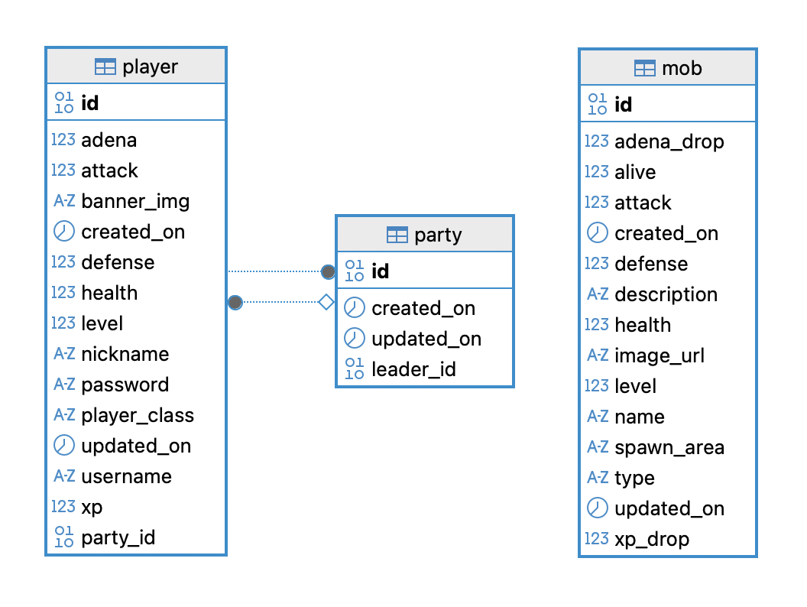

## Configuration Properties

You are provided with two YAML files:

* **class-details.yaml**
* **mob-details.yaml**

Each file must be loaded into the Spring application context using the corresponding configuration class. Use the two provided and empty property classes located in the main.property package: **ClassProperties.java** and **MobProperties.java**

Complete each class so it correctly maps the contents of its respective YAML file. The data must be accessible throughout the application for: Generating mobs based on mob-details.yaml and calculating player class stats and boosters from class-details.yaml

## Functionalities

**User Authentication and Authorization**

Implement **GET** **/**

* Returns the *index.html* view.
* The page must include two buttons: one leading to the registration page (/register), and one to the login page (/login).



Implement **GET /register**

* Returns the *register.html* view.
* The view contains a registration form with the following fields:
  + Username
  + Password
  + Nickname
* Add server-side validation: **all fields must be between 4 and 16 characters** long.
* This page supports “**Log In**” link that must lead to login page
* This page supports “**X**” link that must lead to index page

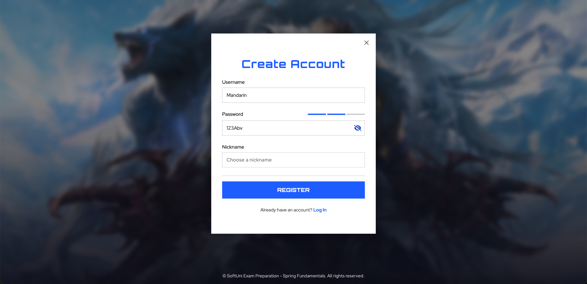

Implement **POST /register**

* Registers a new player in the system.
* Every registered player must:
  + Start with **level 1**.
  + Start with **100 XP**.
  + **Not** have a selected class (class is selected later).
  + Password must be **securely hashed**
* After successful registration, redirect the user to */login*.
* Validation messages must be displayed upon form submission if the values are invalid.

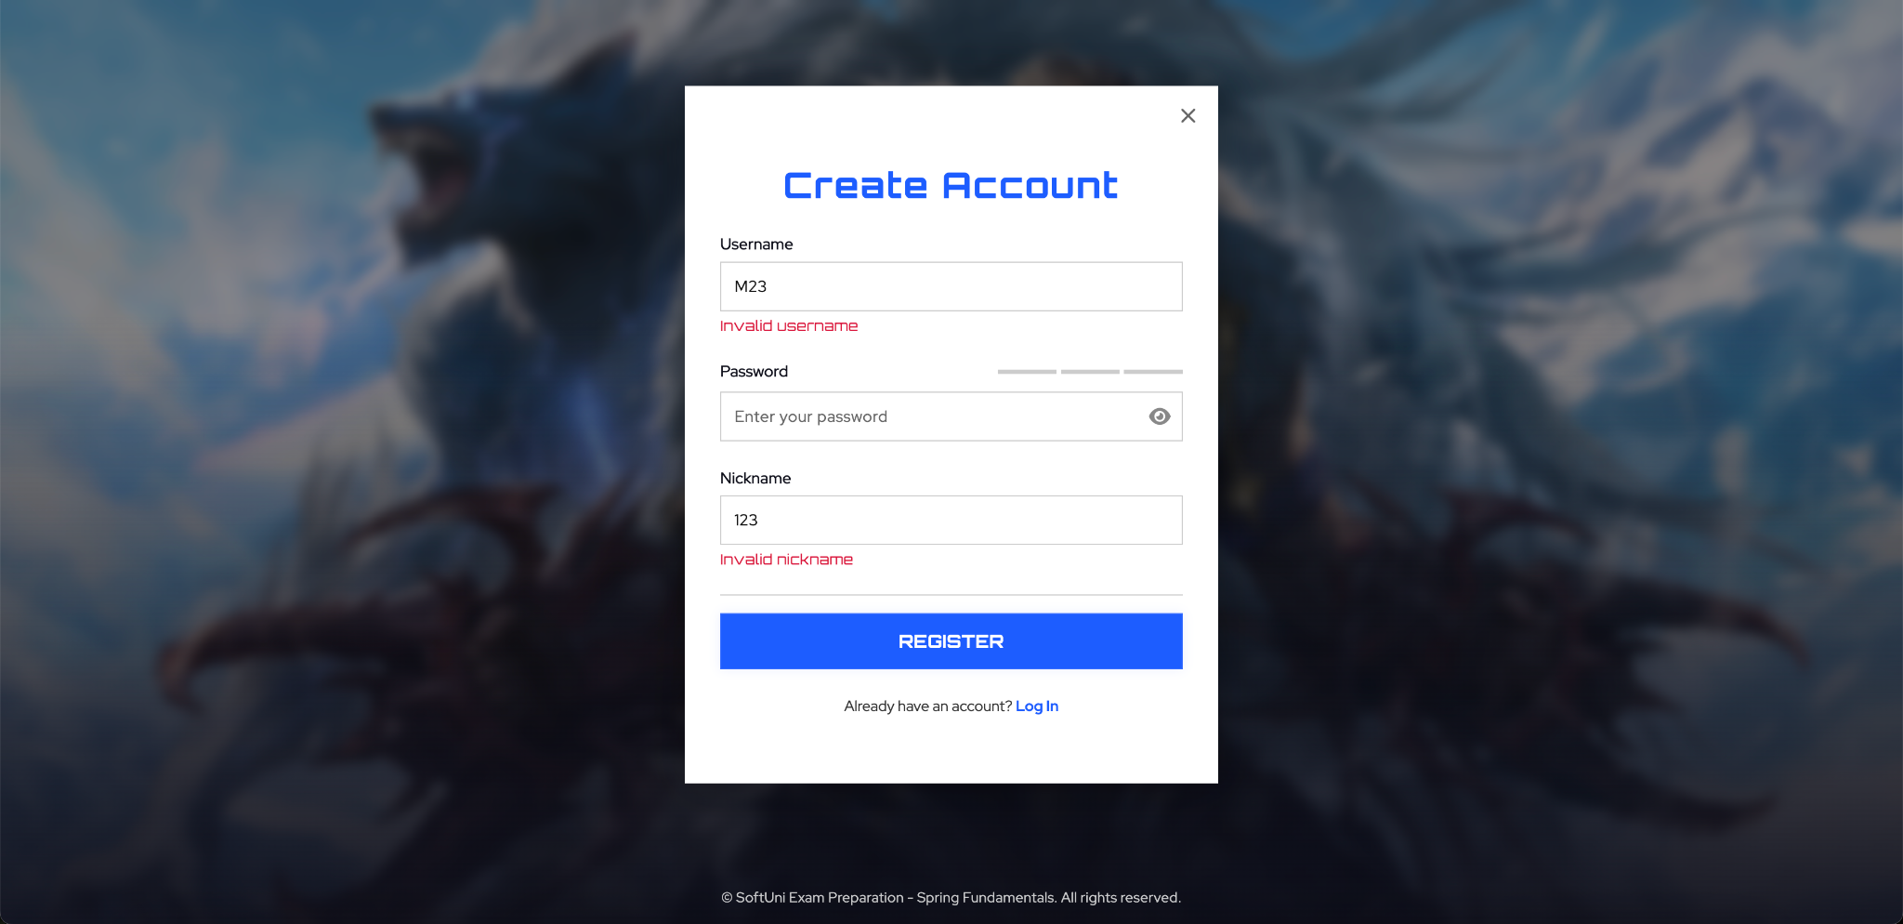

Implement **GET /login**

* Returns the *login.html* view.
* The view must contain a login form with:
  + Username
  + Password
* No data validation on this form is needed.
* This page supports “**Create one**” link that must lead to register page
* This page supports “**X**” link that must lead to index page

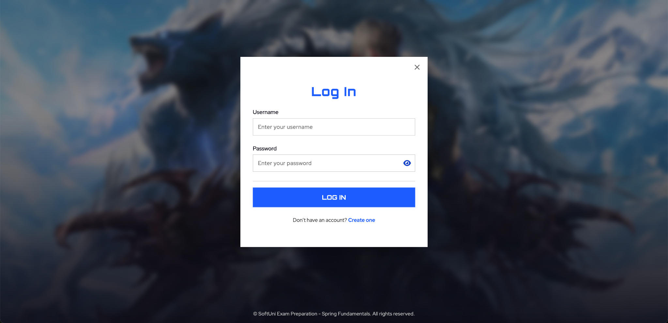

Implement **POST /login**

* Check if such a user exists and the password is correct.
* On correct user data, stores the player’s ID in the session under the attribute user_id.
* On incorrect user data, throw an exception and do not allow the login to happen.
* Redirects the user to /lobby

Implement **GET /logout**

* Invalidates the session.
* Redirects the user to the index page.

**Class Selection**

Implement **GET** **/class**

* Returns the class.html view.
* This page allows the user to select one of the available player classes.

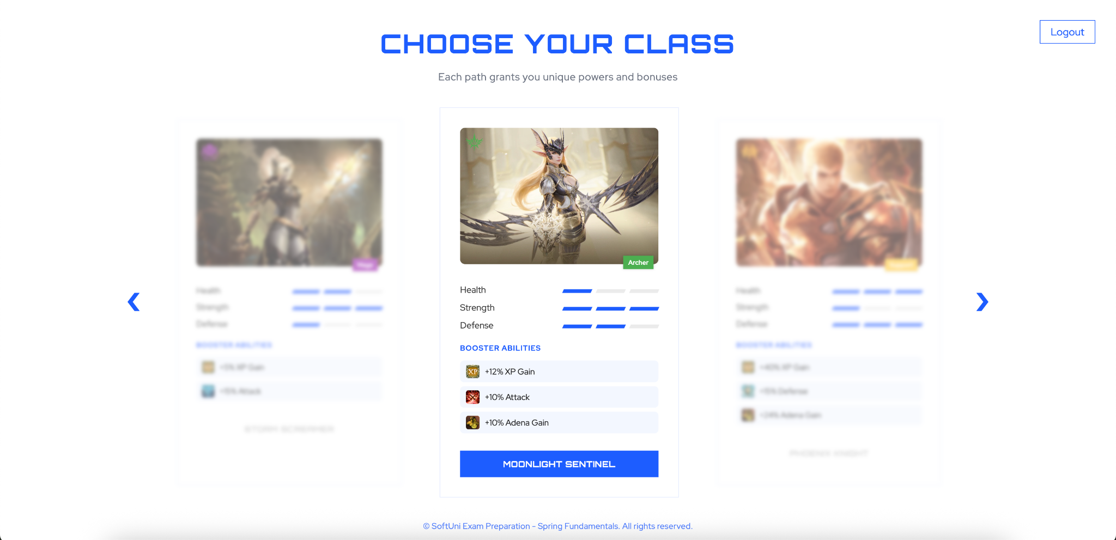

Implement **PATCH /players/me/class**

* The *class.html* view will show all available class cards, each with a button that selects that class.
* On button click, a request must be sent to this endpoint to update the player's class.
* You must implement the mechanism for selecting the correct class yourself.
* On class selection:
  + Set the player's class and banner image.
  + Calculate and set stats:  
    **Attack** = attackFactor × level  
    **Defense** = defenseFactor × level  
    **Health** = healthFactor × level
* A **class-details.yaml** file and **empty ClassProperties.java** class are provided. You must load the YAML content on application startup. Use it to fetch stats factors and other class data during class selection.
* After successful class selection, redirect the user to the lobby page.

Players **must not** be able to access /lobby or any game pages (e.g. /mobs) unless they have selected a class.

* You must enhance the interceptor or add a new one to enforce this restriction.
* If the player has not selected a class, redirect them to /class.

## Mob System

Implement a process that spawns 1 mob for each level range automatically **every 1 minute**.

* A mob-details.yaml file and an empty MobProperties.java class are provided. You must load the YAML file content into the application context when the project starts. Use this data to populate newly spawned mobs (name, level range, spawn area, base stats, drop values, etc.).
* For each scheduled execution:
* You must spawn exactly **1 mob of each** provided in the yaml list.
* For each spawned mob:
  + For each property given as a range (e.g. level), randomly select a value within that range. Choose mob type on random as well.
  + Calculate base stats as:
    - Health = health factor × mob level
    - Attack = attack factor × mob level
    - Defense = defense factor × mob level
  + Then apply a multiplier to stats based on mob type:
    - COMMON: no change
    - BLUE_CHAMPION: increase health, attack, and defense by 5%
    - RED_CHAMPION: increase health, attack, and defense by 10%
  + Apply a multiplier to drop values:
    - COMMON: no change
    - BLUE_CHAMPION: XP and Adena ×2
    - RED_CHAMPION: XP and Adena ×3

**Lobby**

Implement **GET /lobby** endpoint.  
Returns the lobby.html view.  
Only accessible if the player has selected a class.

The view must include:

* **Header**: Display player’s Adena and a “Logout” button.
* **Player Panel**: Show nickname, level, class name, and stats (health, attack, defense). Load and display booster abilities from class-details.yaml.  
  All stat values must be formatted with **exactly two digits after the decimal point**.
* **Latest Mobs Panel**: Display the 3 most recently spawned mobs. Show image, name, level, type, spawn area, spawn time, stats, and description.  
  Stats must be shown with **exactly two digits after the decimal point**.  
  Type must be visually styled and labeled: **Red Champion**, **Blue Champion**, **Common**.
* **Enter Farm Zone Button**: Triggers navigation to the farm zone.
* **Party Panel**:
  + If the player is in a party, show up to 3 members (including themselves).
  + If not, display the default party-empty section.
  + Show a **“Dismiss Party”** button if the player is in a party. Clicking it must send a DELETE request that removes all players from the party (without deleting the party record itself).
  + Show an **“Invite Player”** button if the party has fewer than 3 members.
    - Clicking opens a modal (already implemented) with a list of eligible players:
      * Have selected a class
      * Are not in a party
      * Are not the current player
    - Each player entry includes an **“Invite”** button that sends a POST request to create or update a party:
      * The sender becomes the leader (if creating a new party).
      * The invited player becomes a member.

**Rules**:

* Players cannot invite themselves.
* Players cannot invite someone that is already in a party.
* A party can have a maximum of 3 members.
* Any player (leader or not) can invite others if there is space.
* Any player can dismiss the party they are in.

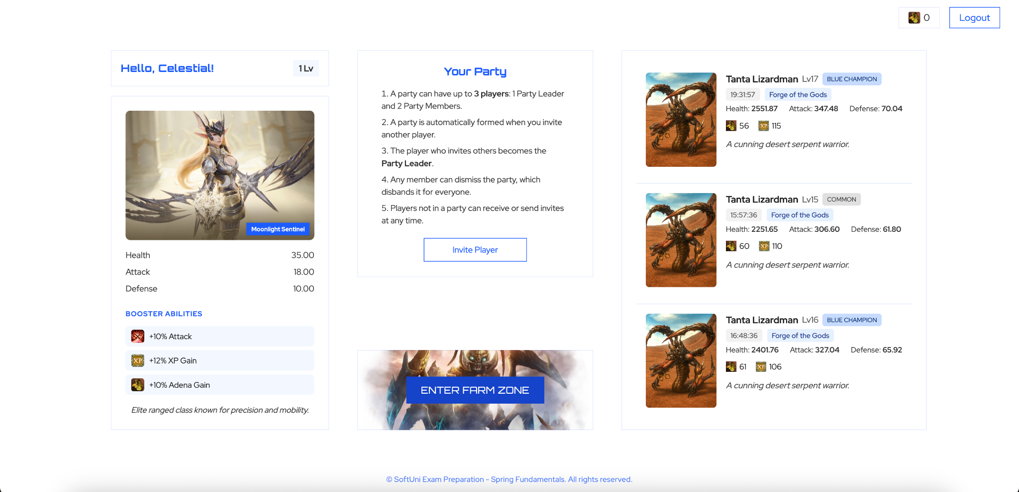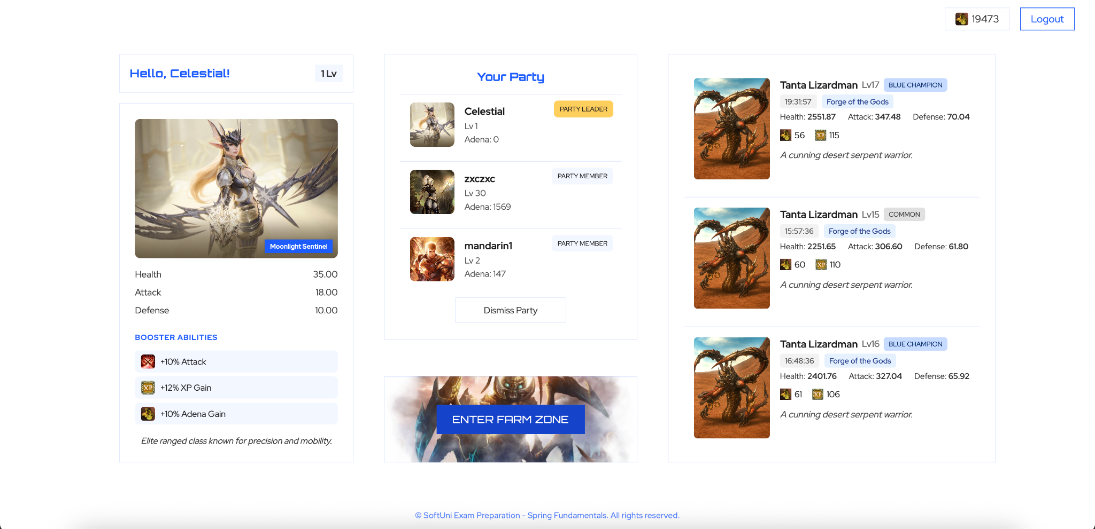

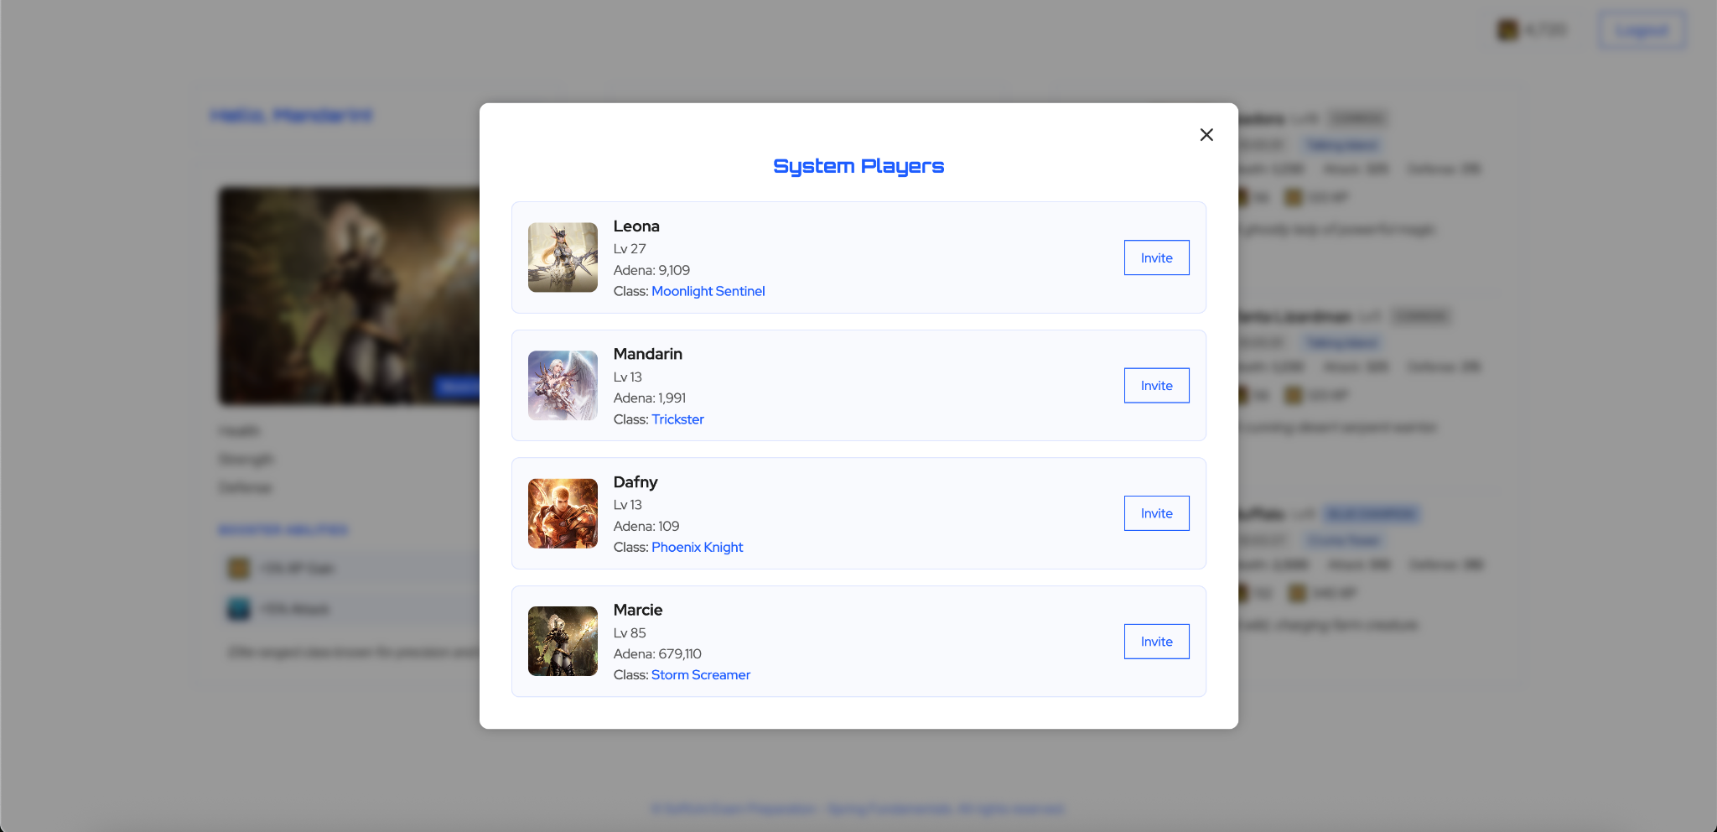

**Farm Zone and Fight**

Implement GET /mobs endpoint.  
Returns the farm-zone.html view.

* Implement the header row: Adena, Exit Zone, Logout
* Display all system mobs, grouped into:
  + Level 1–10 and Level 11–20
* Each mob entry must include:
  + Name, image, level, type, spawn area, spawn time
  + Stats: health, attack, defense
  + XP and Adena drop
  + Status: Alive or Defeated
* All stat values must be shown with **no decimal digits**.
* Each mob must have an **“Attack”** button, unless already defeated (in which case display a **“Defeated”** button).

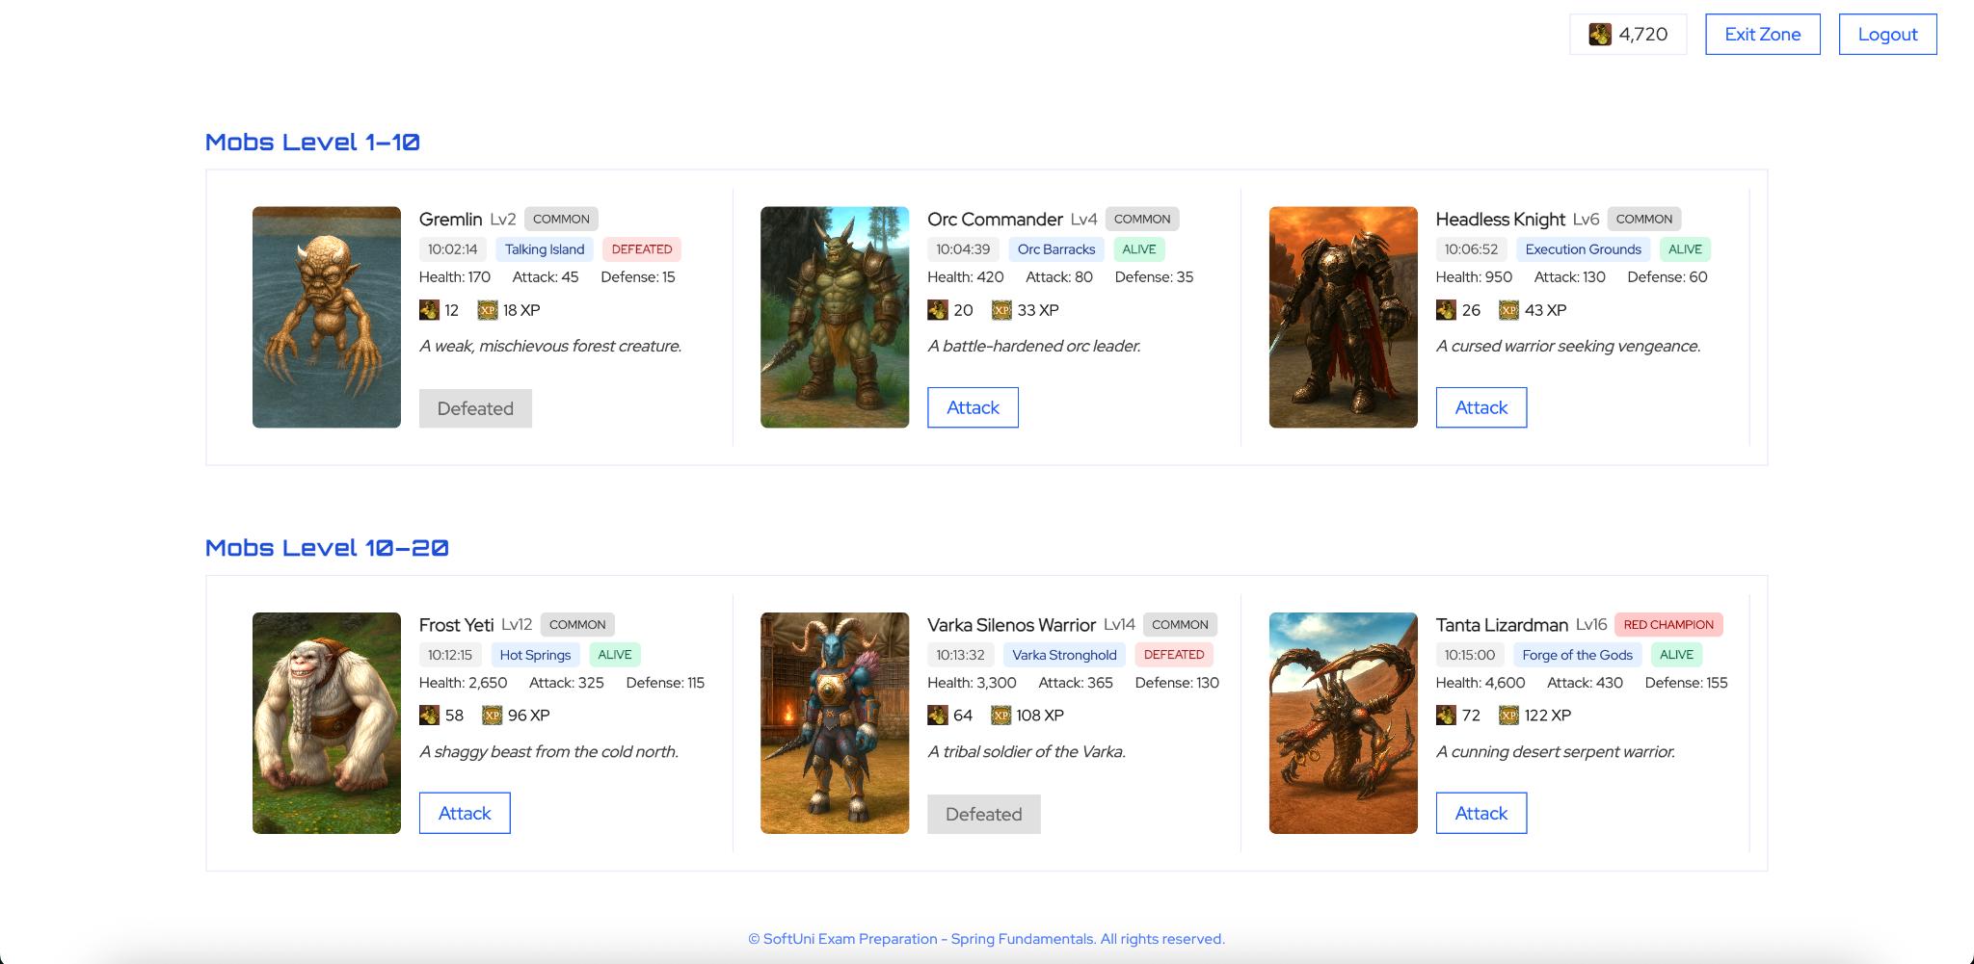

Implement PATCH /mobs/{mobId} endpoint.

* Triggers the fight between the current player and the selected mob.
* After the fight, redirect back to /mobs.
* Pass a FightResult object as a redirect flash attribute.
* Display the fight result in a modal showing:
  + Mob details
  + Fight outcome: **Victory** (if player wins) or **Loss**
  + XP and Adena gained (only if the player wins, otherwise 0)

### Fight Mechanism

* The base fight logic is provided in the file fight_mechanism.md (located in the resources folder). You must use the provided method as the base.
* A **TODO** is left in the method to complete the logic for retrieving and applying the player’s **booster abilities** (Attack Booster and Defense Booster) based on their selected class.
* No other changes to the fight logic are required.

### Fight Outcome

* If the player **wins**:
  + The mob must be marked as **defeated** and is no longer considered alive.
  + XP and Adena are awarded to the player (or their party).
  + If the player is in a party:
    - XP and Adena are split equally among all party members.
    - All members receive the same reduced amount.
  + If the player is not in a party:
    - They receive the full reward.
  + Return FightResult showing what drop the player received from this fight
* If the player **loses**:
  + Return FightResult showing the player received 0 XP and Adena.

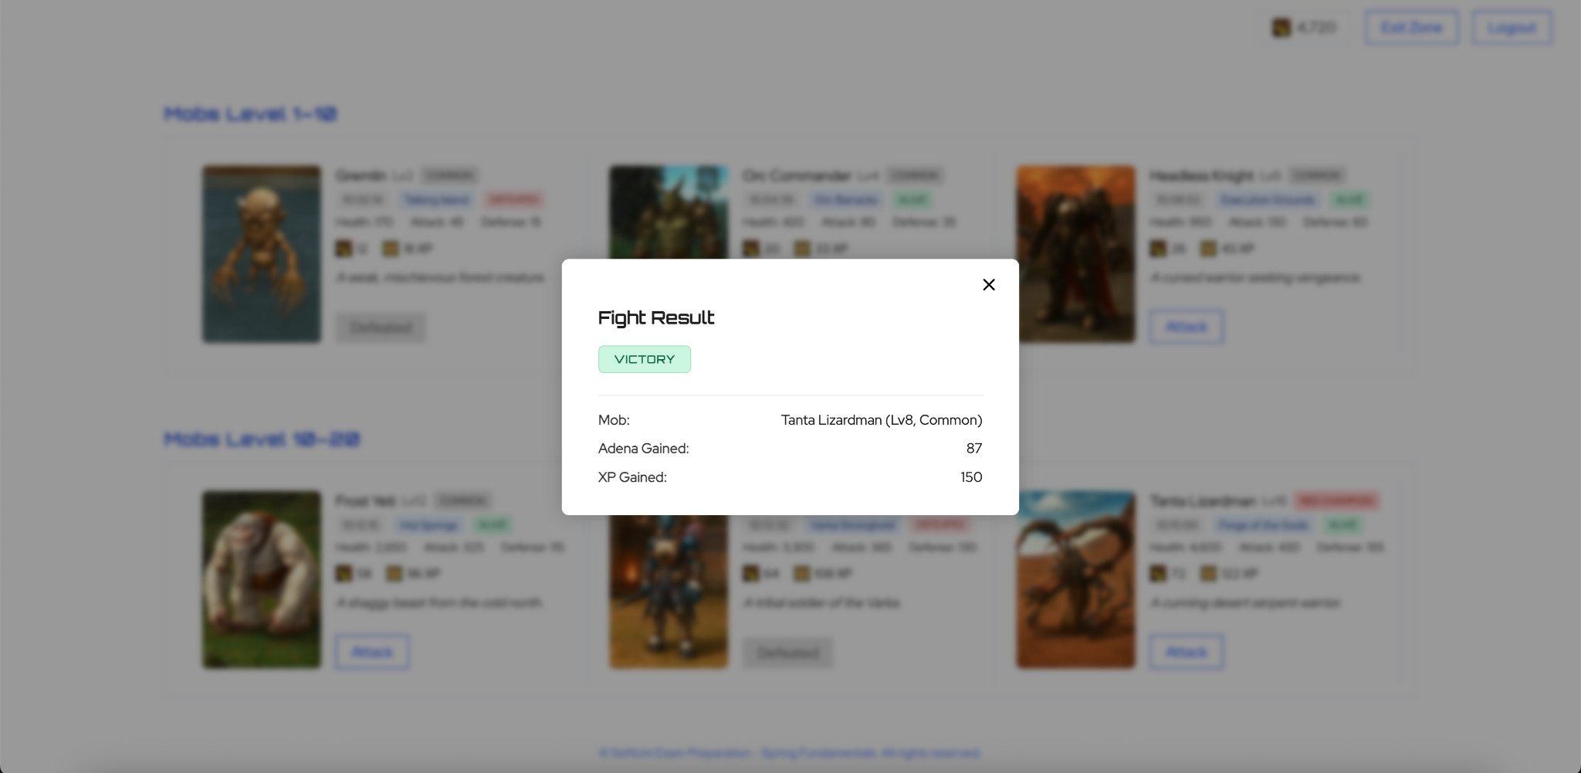

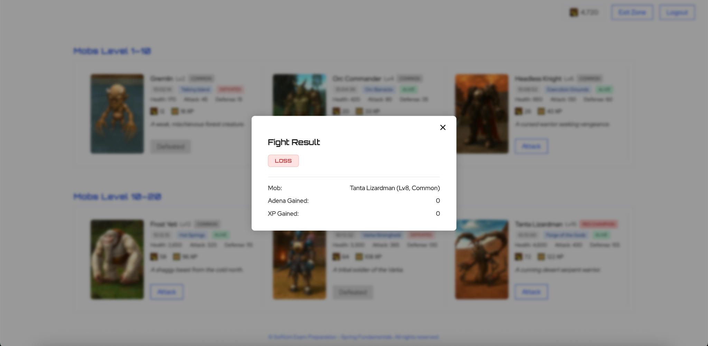

### Reward Modifiers

* If the player has an **XP Booster**, their XP reward is increased by the booster percentage.
* If the player has an **Adena Booster**, their Adena reward is increased accordingly.
* Booster values are defined in class-details.yaml.

### Level Up Mechanism

* A player levels up automatically after a successful fight, **if they have enough total XP**.
* A new level is reached for every 100 XP gained (e.g. 200 XP = level 2).
* Upon leveling up:
  + The player's level is updated.
  + Their stats (health, attack, defense) are recalculated using class-specific factors and the new level.
  + Updated stats and level must be updated in the database.

## Security

* Session-based login (store **user_id** in session)
* Access control:
  + Guests: only /, /register, /login
  + Logged users: the rest of the endpoints

## Validation & Exception Handling

Every form in the application must include **proper server-side validation**. If a user submits a form with invalid data (e.g. missing fields, invalid lengths, out-of-range numbers), the form should be redisplayed with:

* Appropriate **error messages** shown in red next to the specific fields that failed validation.

You must also enforce all **business constraints**, such as preventing mob killing when it is already dead, and throw **exceptions** when these rules are violated. Make sure your system is **resilient to invalid input**. It is normal to encounter White Label Error Page when an exception is thrown.